**ANZAC Day**

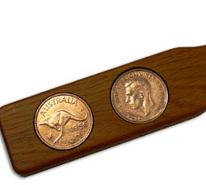

ANZAC Day (25 April) is a public holiday in both Australia and New Zealand. It starts off as a solemn day, with commemorative services and parades, but becomes a day of beer drinking and gambling with the playing of the game “Two Up”. It originally commemorated the first major campaign fought by the Australian and New Zealand Army Corps (ANZAC) during WWI in Gallipoli, Turkey. Nowadays, veterans of all subsequent military campaigns participate.

http://absolutely-australia.com/



During battle, dawn was one of the most favoured times for an attack; soldiers were awoken in the dark so that they would be ready for the enemy. Therefore, the first event of ANZAC Day is a dawn service where wreaths are laid, speeches are delivered, prayers are recited, hymns are sung and the Last Post and Reveille are played by a bugler. The 'Ode for the Fallen' is also read:

http://media2.apnonline.com.au/

*They shall grow not old, as we that are left grow old;*

*Age shall not weary them, nor the years condemn.*

*At the going down of the sun and in the morning*

*We will remember them.*

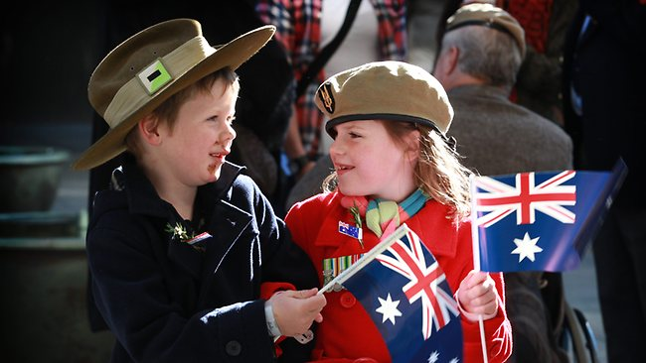Nowadays, young people continue the tradition of ANZAC Day by wearing the war medals of deceased relatives. It is also a day when the enemy is also remembered for the respect it has shown towards the graves and cemeteries of dead ANZAC soldiers. This respect is best epitomised by Turkish President Atatürk, who said: "Your sons are now lying in our bosom and are in peace. After having lost their lives on this land, they have become our sons as well."

http://resources2.news.com.au

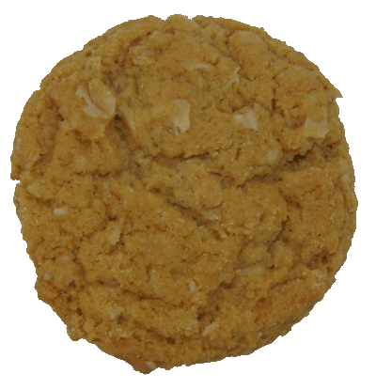

Other ANZAC Day traditions include the consumption of a gunfire breakfast (coffee mixed with rum) and ANZAC biscuits.

http://www.anzacwebsites.com/

1. Write the Slovene translations for the following words:
   1. solemn _______________
   2. commemorative _________
   3. gambling ______________
   4. campaign ______________
   5. corps _______________
   6. wreaths________________
   7. bugler _________________
   8. to decease ______________
   9. to epitomise ____________
2. Identify the WHEN, WHY, WHAT, WHERE & WHO of the text.

|  |  |
| --- | --- |
| **WHEN?** |  |
| **WHY?** |  |
| **WHAT?** |  |
| **WHERE?** |  |
| **WHO?** |  |